**Theme Documentation**

Please make sure you have Drupal install on your server. If you need help please refer to this guide https://drupal.org/documentation/install/beginners

**Info**

Sheena’s theme is a single page layout Drupal theme based on the Skeleton and BlueMasters template published by Smashing Magazine.

**Features**

* Responsive layout(7.x-2.x)
* Sheena theme is available at <https://github.com/sheenasheen/parallax>
* Includes Flexslider as an alternative to a background image
* A total of 22 content areas and 8 sections in the navigation

**Installation**

Install Sheena theme the same way you install any modern drupal theme you can read full documentation on installation [here](https://drupal.org/node/456)

**Basics**

**How to change the logo**

While logged into the site as an administrator, in the top menu bar select Appearance-> And Settings for the selected theme. Scroll to Logo image settings and upload a new image

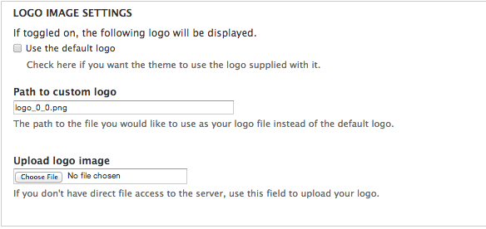

**Change the Favicon**

While logged into the site as an administrator, in the top menu bar select Appearance-> And Settings for the selected theme. Scroll to Short Icon settings and upload a .ico file

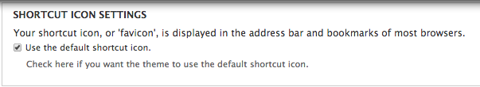

**Using Shortcodes**

In order to use the shortcodes included in the skin (ensure that you have installed the included blocks module and that it is enabled) go to structure-> block -> add block. Inside the text editor paste in and modify the html to fit your needs.

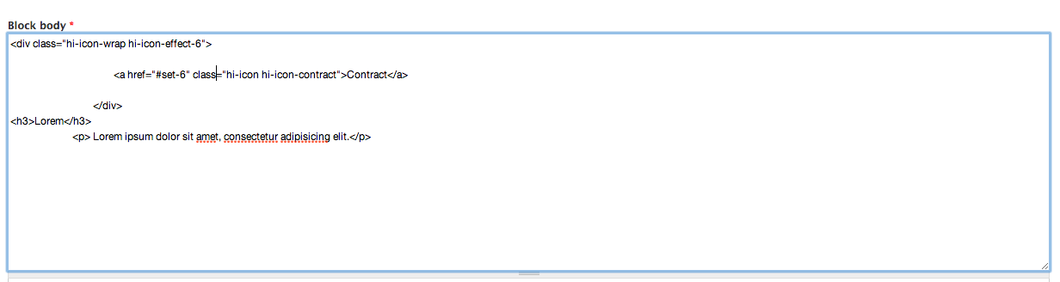

Then select the Text format and ensure that Full HTML is selected

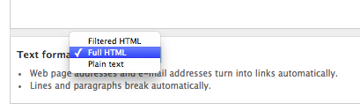

and that you specify the region that you want the block to display in.

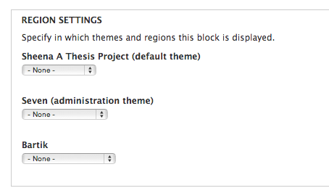

**Shortcodes Available**

**Services Icon Hovers:**

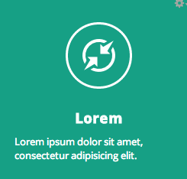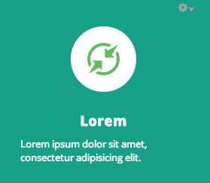

To Achieve these hovers modify the following shortcode **:**

<div class="hi-icon-wrap hi-icon-effect-6">

<a href="#set-6" class="hi-icon hi-icon-contract">Contact</a> </div>

Other Included Icons:



Row 1:

* hi-icon hi-icon-support
* hi-icon hi-icon-locked
* hi-icon hi-icon-earth
* hi-icon hi-icon-cog
* hi-icon hi-icon-clock

Row 2:

* hi-icon hi-icon-videos
* hi-icon hi-icon-list
* hi-icon hi-icon-refresh
* hi-icon hi-icon-images
* hi-icon hi-icon-mobile

Row 3:

* hi-icon hi-icon-screen
* hi-icon hi-icon-pencil
* hi-icon hi-icon-link
* hi-icon hi-icon-mail
* hi-icon hi-icon-location

Row 4:

* hi-icon hi-icon-archive
* hi-icon hi-icon-chat
* hi-icon hi-icon-bookmark
* hi-icon hi-icon-user
* hi-icon hi-icon-contract

Row 5:

* hi-icon hi-icon-star

**Portfolio Image Lomo Vingette Effect**

Black:



<div class="lomo_black">

<img src="/sites/all/themes/bluemasters%207/img/Wave-1.jpg" alt="" />

</div>

White:

<div class="lomo_white">

<img src="/sites/all/themes/bluemasters%207/img/img09.jpg" alt="" />

</div>

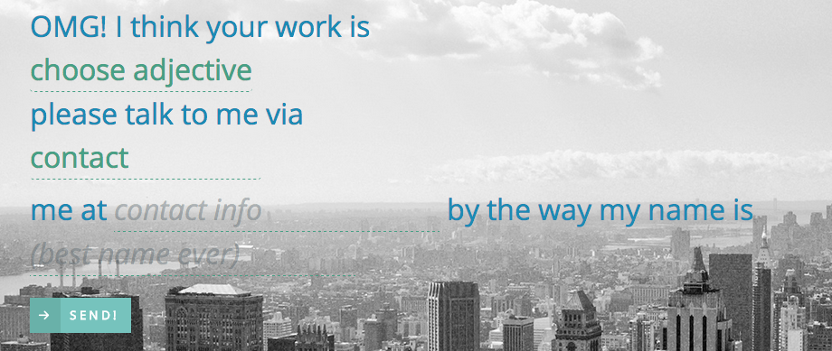

**Natural Language Form**

<form id="nl-form" class="nl-form">

OMG! I think your work is

<select>

<option value="1" selected>choose adjective</option>

<option value="2">Fantastic</option>

<option value="3">Awesome</option>

<option value="4">the best ever</option>

<option value="2">meh.. it was ok</option>

</select> please talk to me via <select>

<option value="1" selected>contact</option>

<option value="2">call</option>

<option value="3">email</option>

<option value="4">snail mail</option>

<option value="2">messager pigeon</option>

</select>me at <input type="text" value="" placeholder="contact info"/> by the way my name is <input type="text" value="" placeholder="(best name ever)" />

<div class="nl-submit-wrap">

<button class="nl-submit" type="submit">Send!</button>

</div>

</form>

</div>

</div>

</div>

</div>

**Content Layouts**

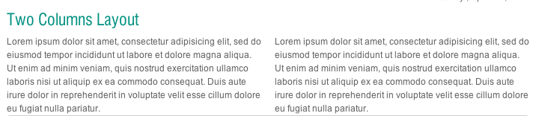

<div id='root'>

<div class='box' id='left-half’>…</div>

<div class='box' id='right-half’>…</div>

</div>

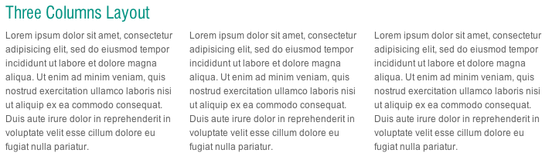

<div id='root'>

<div class='box' id='onethrid’>…</div>

<div class='box' id='twothrid’>…</div>

<div class='box' id='threethrid’>…</div>

</div>

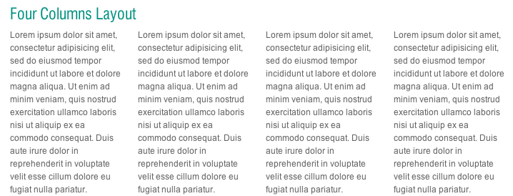

<div id='root'>

<div class='box' id='leftquater’>…</div>

<div class='box' id='middleleftquater’>…</div>

<div class='box' id='middlerightquater’>…</div>

<div class='box' id='rightquater’>…</div>

</div>

**Changing the Menu Item Names**

Go to your Drupal Install and go to Sites-> All -> Themes -> Bluemasters 7 -> page--front.tpl.php (WARNING YOU WILL NEED A TEXT EDITOR TO PROPERLY IMPLEMENT THESE CHANGES) Find the section with the div id =”Navigation” and change the items highlighted below to whatever you want your section names to be­­­

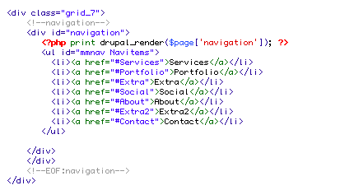­

**Using the Superfish Version of the menu**

If the Superfish version of the menu is preferred (note this has been prestyled) Go to your Drupal Install and go to Sites-> All -> Themes -> Bluemasters 7 -> page--front.tpl.php (WARNING YOU WILL NEED A TEXT EDITOR TO PROPERLY IMPLEMENT THESE CHANGES) navigate to <div id="navigation"> delete from line 55 to 67 and paste this in its place

<?php if ($page['navigation']) :?> <?php print drupal_render($page['navigation']); ?> <?php else : if (module_exists('i18n_menu')) { $main_menu_tree = i18n_menu_translated_tree(variable_get('menu_main_links_source', 'main-menu')); } else { $main_menu_tree = menu_tree(variable_get('menu_main_links_source', 'main-menu')); } print drupal_render($main_menu_tree); endif; ?> </div>

**Implementing the Flexslider**

The skin came with a default slider which was removed but can easily be re-implemented (note this has not been styled) Go to your Drupal Install and go to Sites-> All -> Themes -> Bluemasters 7 -> page--front.tpl.php (WARNING YOU WILL NEED A TEXT EDITOR TO PROPERLY IMPLEMENT THESE CHANGES) navigate to the line that says <div id= “banner”> and paste in the following code:

<div id="banner">

<?php print render($page['banner']); ?>

<?php if (theme_get_setting('slideshow_display','bluemasters')): ?>

<!--#slideshow-->

<div id="slideshow">

<div class="flexslider">

<ul class="slides">

<!-- slider-item -->

<li class="slider-item">

<div class="slider-item-image">

<a href="<?php print url('node/3'); ?>"><img src="<?php print base_path() . drupal_get_path('theme', 'bluemasters') . '/images/slide-image-3.jpg'; ?>"></a>

</div>

<div class="slider-item-caption">About Bluemasters</div>

</li>

<!-- EOF: slider-item -->

<!-- slider-item -->

<li class="slider-item">

<div class="slider-item-image">

<a href="<?php print url('node/2'); ?>"><img src="<?php print base_path() . drupal_get_path('theme', 'bluemasters') . '/images/slide-image-2.jpg'; ?>"></a>

</div>

<div class="slider-item-caption">Our Portfolio</div>

</li>

<!-- EOF: slider-item -->

<!-- slider-item -->

<li class="slider-item">

<div class="slider-item-image">

<a href="<?php print url('node/1'); ?>"><img src="<?php print base_path() . drupal_get_path('theme', 'bluemasters') . '/images/slide-image-1.jpg'; ?>"></a>

</div>

<div class="slider-item-caption">Creation of Beaches</div>

</li>

<!-- EOF: slider-item -->

</ul>

</div>

</div>

<!--EOF:#slideshow-->

<?php endif; ?>

</div>

**Changing out the Background Image**

To Change out the background image simply navigate to the styles.css file located approximately in (Your Site name) -> Sites -> All -> Themes -> BlueMasters 7 -> Style.css. Find the BODY section and change the background URL to your preferred image.

BODY

{ padding: 0;

background: url(/all/themes/bluemasters%207/images/Doutone_Mountians.jpg) repeat fixed 0% / 100%;

font: 0.96em / 1.4 open_sansregular, sans-serif;

color: #666666;

}

For ease of Code readability and copy and paste ability please refer to the Theme_Documentation.txt located in this theme.